

11th Infrared and Raman Users Group Conference

5-7 November 2014, Museum of Fine Arts, Boston

General Information

Welcome to IRUG11. Please see below for some general information about traveling to Boston and logistics during the conference.

Transportation from Logan Airport
The Logan International Airport website lists several options for making your way into the city.

1. Taxi stands are available outside each terminal. The cost should be around $30-40 USD.

2. For a less expensive alternative: if you are traveling to either The Lenox Hotel, The Eliott Hotel, or another in the Back Bay area, we recommend taking the Back Bay Logan Express bus (because the “Government Center” subway station is now closed for renovation). Wait at the Logan Express station outside the terminal; there are several different Logan Express lines, so be sure to take the Back Bay bus.
- $5 USD, credit card only, payment is collected at the last terminal (terminal E).
- Stops first at Copley Square in front of Fairmont Copley Plaza Hotel, then at 900 Boylston Street in front of the Hynes Convention Center. (When traveling TO the airport, note that the pickup location in Copley Square is at 650 Boylston Street in front of the “Copley” subway station near the Boston Public Library.)
- The Lenox Hotel is a short walk from the Copley Square stop. The Eliott Hotel is an easy walk from the Hynes Convention Center stop as well, but you can also get off the Logan Express bus at Copley Square and take the subway at “Copley” (Outbound on B, C or D Green Line) to “Hynes Convention Center.”
“Copley” subway station: note that Inbound and Outbound Lines have different entrances and are not connected
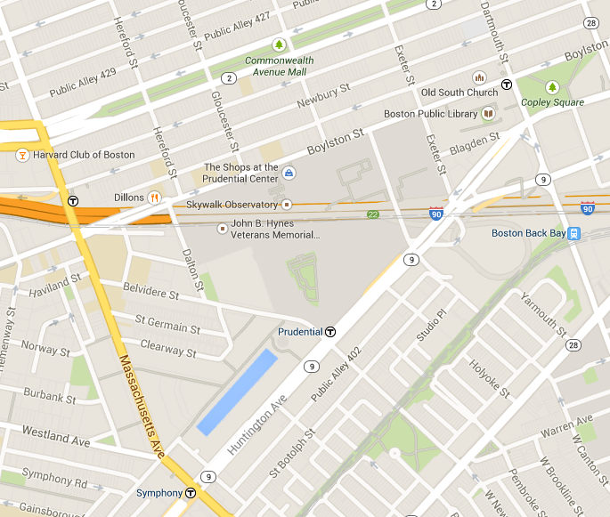
The MFA is located at 465 Huntington Avenue, 3 stops from “Prudential” station on the E Green Line, or 4 stops from “Copley”)
The Lenox Hotel
61 Exeter Street
Boston, MA 02116
The Eliott Hotel
370 Common-wealth Avenue,
Boston, MA 02215
“Hynes Convention Center” subway station (B, C and D Green Lines only)
Logan Express Copley Square drop off, in front of Fairmont Copley Plaza Hotel
Logan Express Hynes Convention Center drop off

3. For those traveling to Cambridge, use the Silver Line Route SL1 which stops at each airport terminal and the “South Station” subway station on the Red Line. The ride to “South Station” is free, but you’ll need to pay the normal fares if traveling further via subway or bus. From “South Station,” take the Alewife Red Line to reach Cambridge/Harvard/MIT.

Those staying in the Back Bay neighborhood can also use the Silver Line SL1. The Red Line connects with the Green Line at “Park Street.” Please see the MBTA website and MBTA Rapid Transit Map for more information about connections.

Transportation to Logan Airport
If you are leaving directly from the Museum, public transportation usually takes 30-45 minutes, while taxi rides are faster at 20-30 minutes. Please give yourself extra time during rush hours.

During the day, there are often many taxis dropping off visitors at the Huntington Avenue Entrance. You can also call these local taxi companies:
– Boston Cab Association: 617-536-5010
– Metro Cab: 617-782-5500
– Ambassador Cab and Yellow Cab: 617-492-1100
– Top Cab and City Cab: 617-536-5100

Transportation to the MFA
1. The easiest way to get to the MFA is on the “T” (MBTA subway system). The “Museum of Fine Arts” station on the E Green Line is the closest stop (right across the street). Subway fare is $2.10 using a CharlieCard, or $2.65 using a CharlieTicket (paper ticket) or cash.

From The Lenox Hotel: Walk along Boylston Street to the “Copley” station and take the Outbound E Green Line to “Museum of Fine Arts” (4 stops, about 10 minutes). The Green Line branches off into B, C, D and E Lines at the “Copley” station; the branch letter will be displayed on each train. (Note that Inbound and Outbound Lines have different entrances across the street from one another and are not connected.)

From The Eliott Hotel, there are several options:
- Walk south on Massachusetts Avenue to the corner of Huntington Avenue (about 20 minutes) where the “Symphony” station is located. Take the “Symphony” E Line train to “Museum” (2 stops).
- Walk through Hynes Convention Center to the “Prudential” station. (The convention center connects to the same complex that houses The Shops at Prudential Center.) Take the E Line to “Museum” (3 stops).
- The closest “T” stop to the Eliott is the “Hynes Convention Center” (B, C and D Lines only). You will need to backtrack one stop (Inbound to “Copley”), exit the station and cross the street to the Outbound “Copley” entrance (which does mean paying the fare twice), then take the E Line to “Museum” (4 stops).

2. For those who plan to drive, please see the parking section on the MFA website for more information. There are three parking areas (Huntington Lot, Fenway Lot, and the garage), and all are accessible from Museum Road (see map on page 3). Remember to keep your ticket with you. Parking is $29 maximum for the day (less if you are staying less than 6 hours). You can pay in the garage lobby, or by credit or debit card at the exit lanes of the two lots.

Entry to the Museum
On all three days, you may use either the Huntington Avenue Entrance or the State Street Corporation Fenway Entrance. Because the Museum will not be open to the public when you arrive, an MFA staff member will meet you at the entrance, give you an event admission ticket, and escort you inside. Doors will open at:
– 9:00am on Wednesday, November 5th
– 9:15am on Thursday, November 6th
– 9:15am on Friday, November 7th
(Please see the Program for more details.)

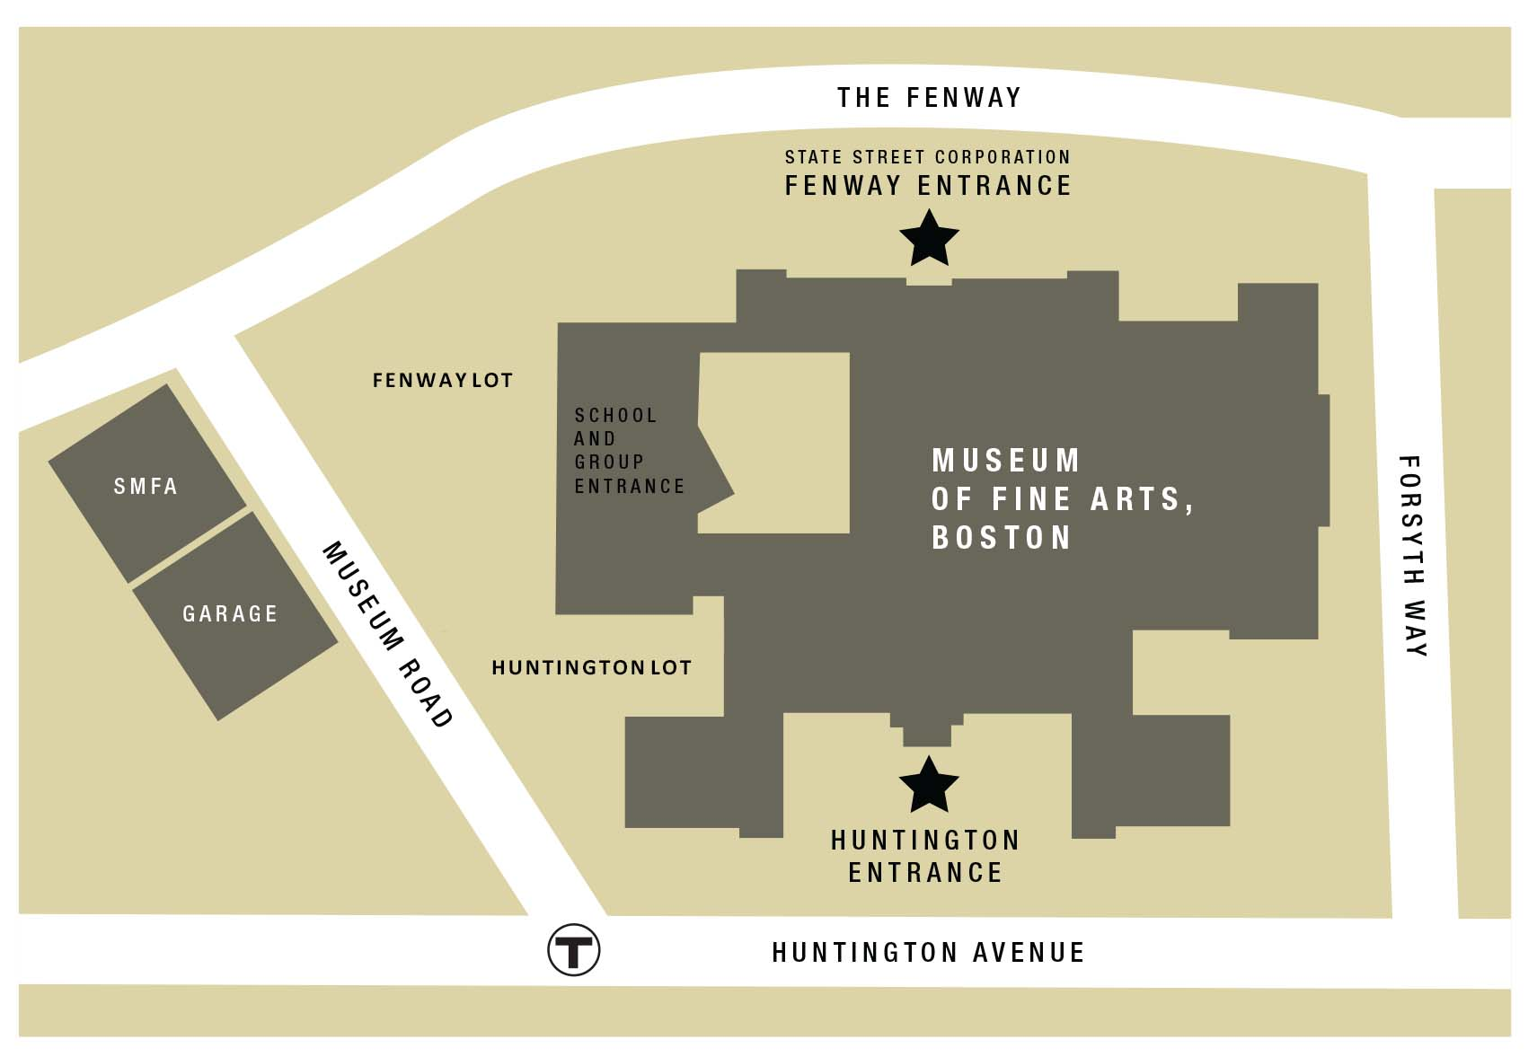

The Fenway entrance is closer to Alfond Auditorium, the conference meeting space, while the Huntington entrance is closer to the “Museum of Fine Arts” subway station.

If you have heavy coats or luggage, please check them with Coat Check, which are available near both entrances. Your MFA staff escort can point them out to you.

We will be walking through gallery spaces to reach Alfond Auditorium, so you will not be able to carry any food or drink with you.

During the Day
You are on your own for lunch. The MFA has four restaurants (http://www.mfa.org/visit/dining); please see the Dining Guide in your conference packet for other nearby options in the surrounding neighborhood.

Be sure to keep each day’s event admission ticket with you if you are exiting the Museum at any point during the day, so that you may regain entry for free.

Please also save your name badges. You will receive them during registration on the first day and use it for the duration of the conference.

Poster viewing is scheduled during coffee breaks on Wednesday and Thursday, starting at about 3pm in Riley Seminar Room, but Riley will be open during lunch on both days for those interested. (The Riley Seminar Room is adjacent to gallery space, so we kindly ask everyone not to walk outside of the room carrying food or drink.)

The closest restroom is just outside Alfond Auditorium. Please see the MFA Map and Visitor Guide included in your conference packet for other locations.

There is an ATM machine behind the ticketing desk at the Huntington Avenue Entrance. An MBTA kiosk for buying CharlieCards or CharlieTickets is located there as well.

Lastly, the Museum is open until 9:45pm all three days, so please feel free to explore. (Special exhibitions, “Goya: Order and Disorder” in the Gund Gallery (LG31) and “Jamie Wyeth” in the Torf Gallery (184), are both open during the conference. For more, see http://www.mfa.org/exhibitions or visit the Sharf Visitor Center.)

For Poster Presenters
Poster presenters should plan to arrive at 9am on Wednesday, November 5th, to set up posters in Riley Seminar Room. An MFA staff member will then escort you to Alfond Auditorium for registration (9:15-10am).

Note that the room will be open during lunch, but you need not be present.

Posters should be picked up from Riley Seminar Room at the end of the day on Thursday, November 6th, about 5:30-6pm.

For All Presenters
We have scheduled some time with the MFA audio/video staff so that presenters may run through PowerPoint presentations and make sure everything is working properly. Participation is optional; please reference the Program to see when your run-through (listed in blue) is scheduled.

The audio/video booth at the back of the room is staffed during all presentations to address any problems that might arise.

Lab Tours
For those signed up for lab tours, see below for meeting locations and times:
– Objects and Scientific Research, Wednesday, November 5th: Alfond Auditorium Lobby at 12:05pm
– Furniture and Frame, Thursday, November 6th: Huntington Avenue Entrance Lobby at 9:15am
– Paper and Textile, Thursday, November 6th: Alfond Auditorium Lobby at 11:55am
– Asian (studio 1 and 2), Friday, November 7th: Huntington Avenue Entrance Lobby at 9:15am

Route to Riley Seminar Room (for Coffee breaks and Poster viewing)
From Alfond Auditorium, take the stairs or elevator one level up to Level 1 (area highlighted in yellow).
Proceed straight from gallery 141, exit Foster Gallery 158, and left into Riley Seminar Room 156 (circled in red).

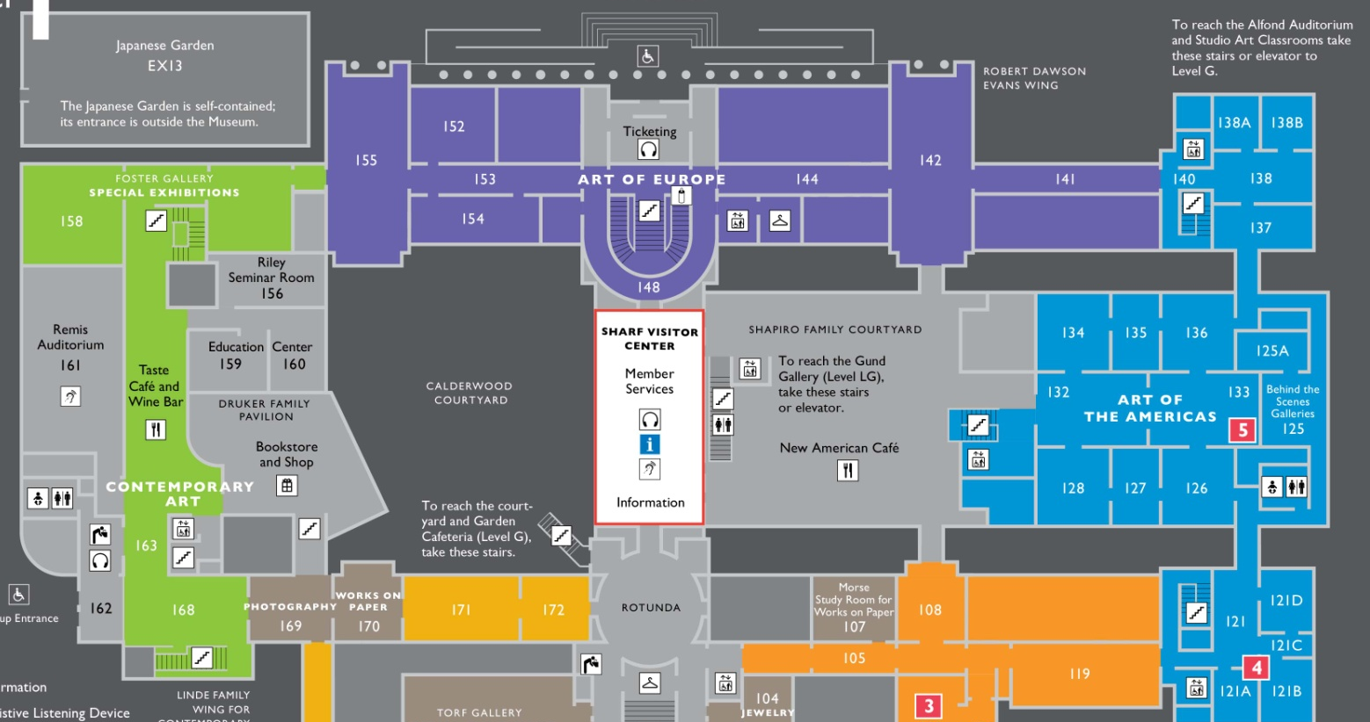

Route to Koch Gallery (for Reception on Wednesday, November 5th)
From Alfond Auditorium, take the stairs or elevator two levels up to Level 2 (area highlighted in yellow).
Proceed straight toward gallery 242, then left through the hemicycle and into Koch Gallery 250 (circled in red).

